**Task 7.1 P**

**Aruj Punia**

**GitHub Link -** [**https://github.com/puniaruj/SIT-313--Secure-Frontend-Application/tree/main/task7.1**](https://github.com/puniaruj/SIT-313--Secure-Frontend-Application/tree/main/task7.1)

**Youtube Link-** [**https://youtu.be/emBFoZ8oemI**](https://youtu.be/emBFoZ8oemI)

**CODE SCREENSHOT**

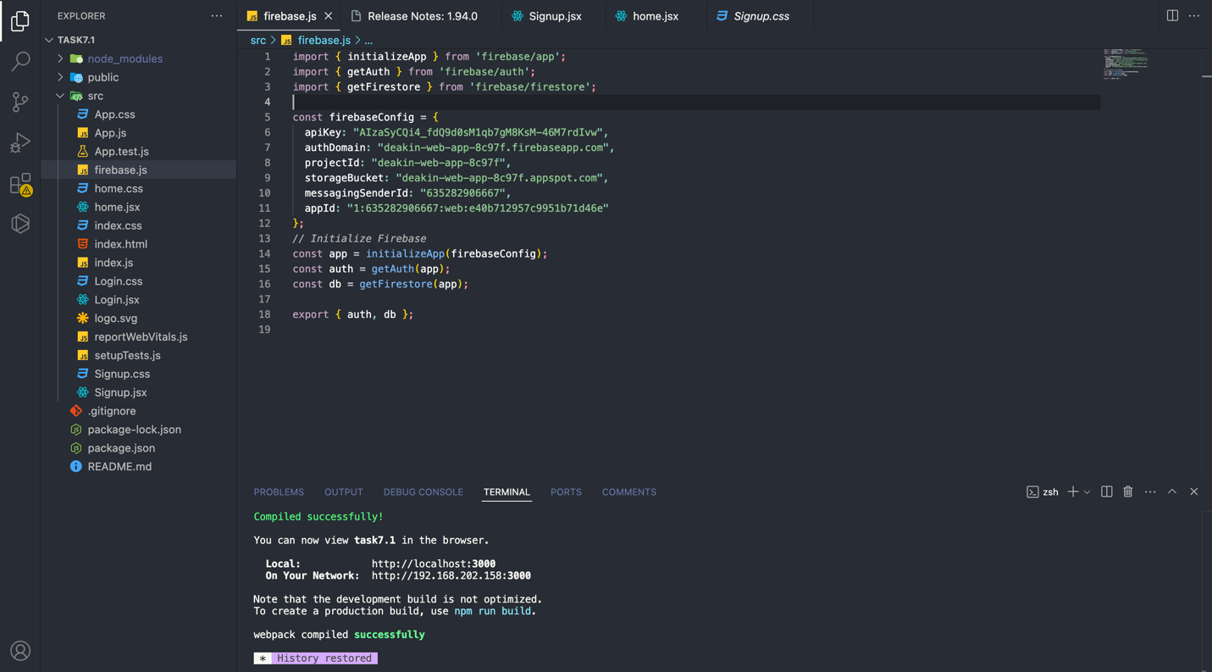

**Website Screenshots-** 